**Instruction on Course Enrollment 2016-2017 Fall Semseter**

1. 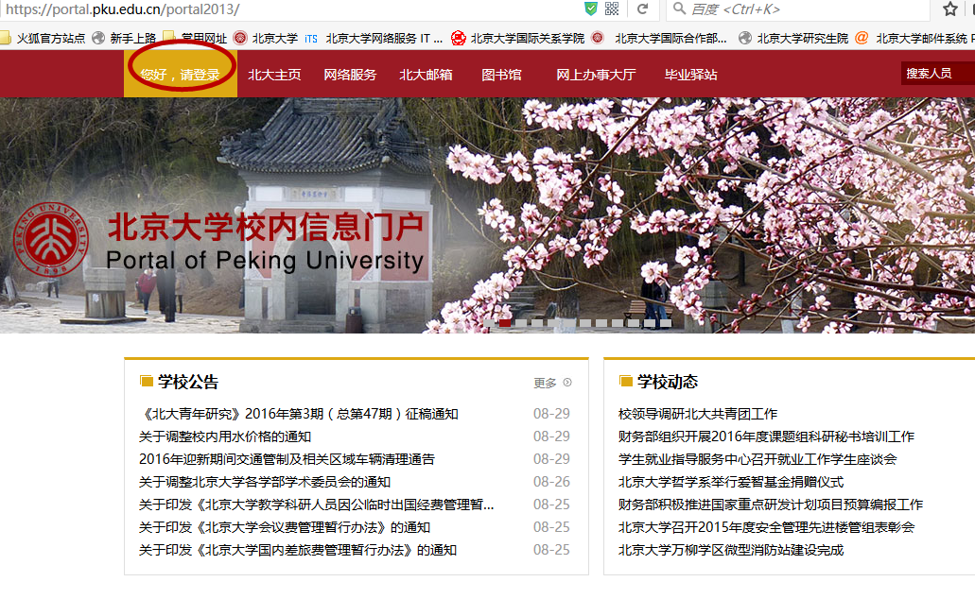Please visit <https://portal.pku.edu.cn/portal2013/> to log in your personal portal by filling in your username and password accordingly.

**Usename: your 8-digital student number**

**Password: your 8-digital date of birth (eg:19900915 for 15th Sept.1990)**

1. 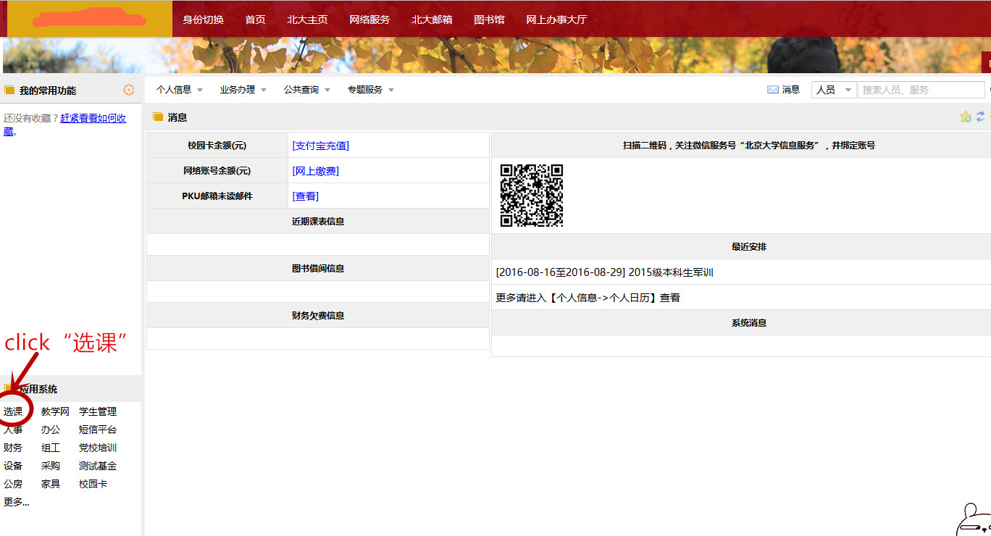After logging into your personal page,click“选课”：

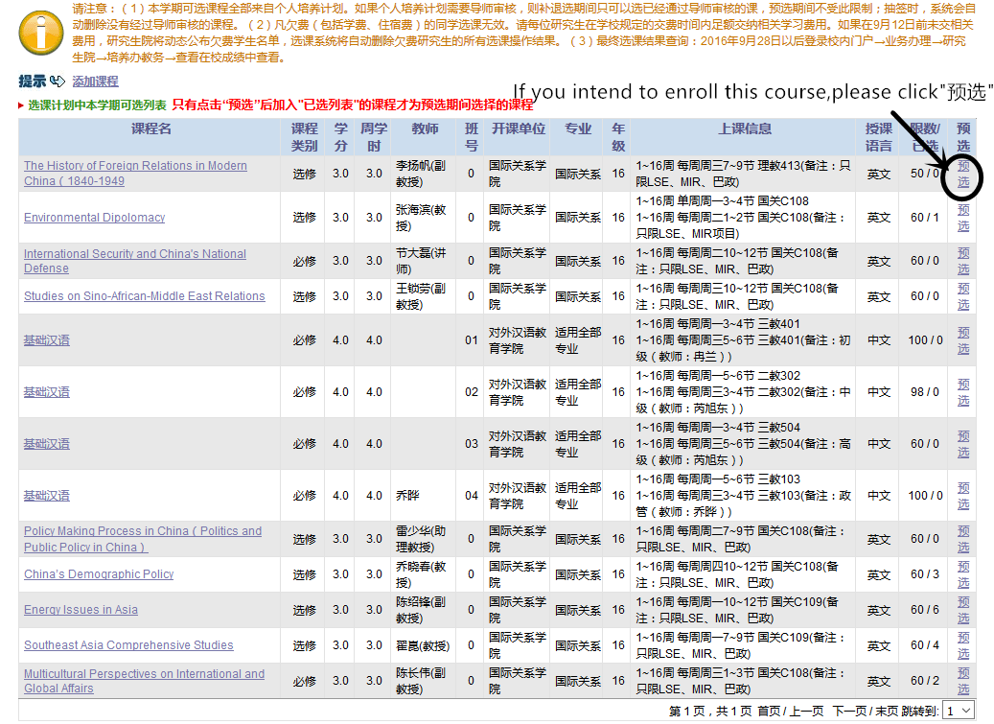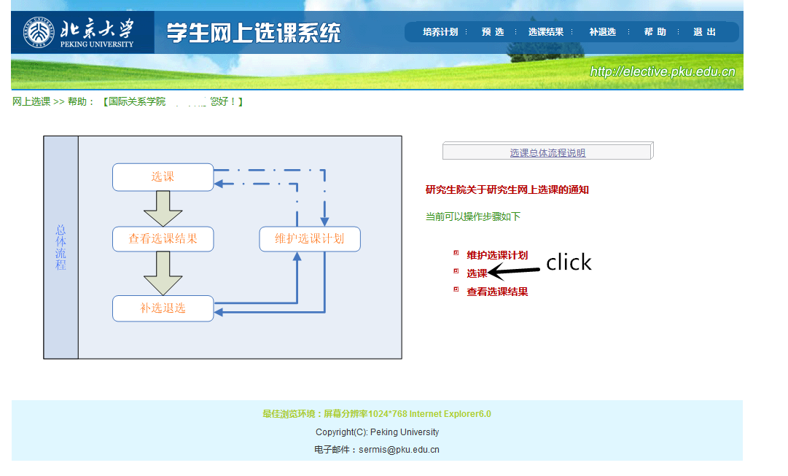

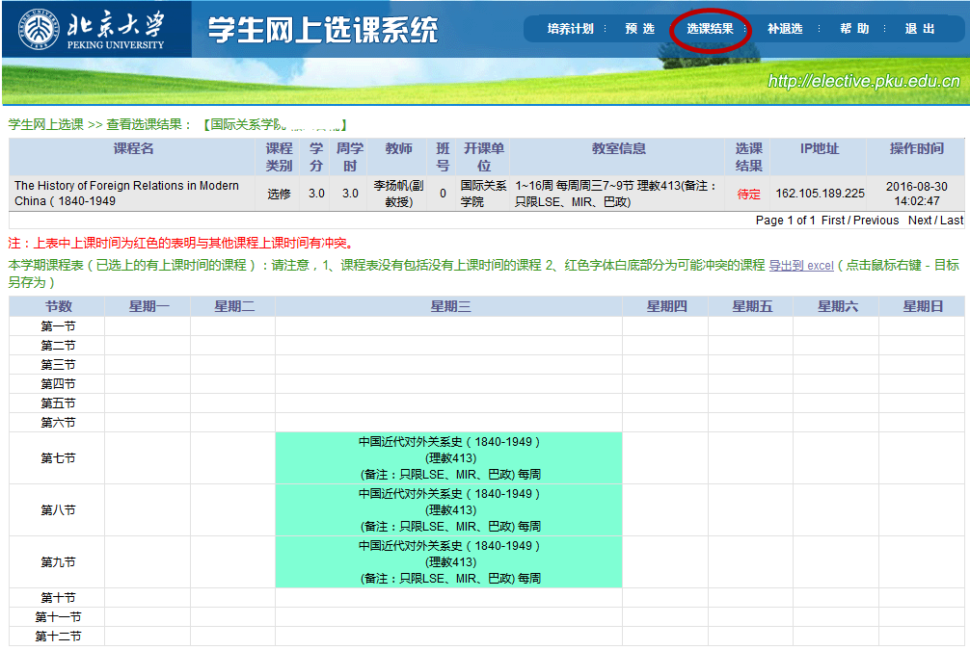3）You can check your course selection result by click“选课结果”：

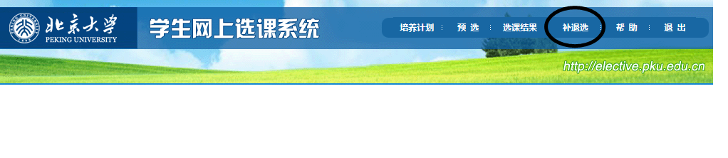4）If you want to add or withdraw a course, please process it via “补退选”  
**Course Enrollment period:**

Results for Preliminary Selection Available: Sept. 13, 2016  
Add and Withdraw: Sept. 13 to Sept. 26, 2016 (8:30am)  
Note: This is the FINAL period that students can make changes to the course enrollment, NO changes can be made afterwards.  
Final Results Available: Sept.28, 2016 (via student portal校内门户→业务办理→研究生院→培养办教务→查看在校成绩中查看)